

**DE LA SALLE UNIVERSITY - MANILA**

**“Code Crawler: An Educational Python Based Game”**

___________________________________

A Term Project

Presented to Sir Ramon Stephen L. Ruiz

In Partial Fulfillment of the

Requirements for the Course Programming Logic and Design Laboratory (LBYCPA1)

___________________________________

by

QUIJANO, Gill Whenzel B. - 12261701

ROBELLON, Jireh G. - 12216283

TALICOL, Matthew Ceazar P. - 12217204

EQ4

Monday: 07:30 - 10:30 , Thursday: 07:30- 10:30

April, 2023

TABLE OF CONTENTS

TABLE OF CONTENTS ………………….…………………………………………………………………… ii

LIST OF FIGURES …..……………………..………………………………………………………………… iii

LIST TABLES ……………..…………………..……………………………………………………………… iii

I. INTRODUCTION ………………………………………..…………………………………………..…… 1–4

1. Background of the Study………………………….………………………………………………..…1-2
2. Problem Statement ……….……………………….…………………………………………………… 2
3. Objectives ……………...…………………………………………………………………….……... 2–3

C. 1 General Objective …………………………………………………………………...…………… 3

C. 2 Specific Objectives …..…...……………………………………………………………………… 3

1. Significance of the Project ……….………………………….………………………………………… 4

II. REVIEW OF RELATED LITERATURE ………………………..…………………………..…………… 5-7

III. METHODOLOGY ………………………………………………….....……………………………….. 7-12

1. Conceptual Framework - IPO Chart …………………………….…………………………..……….7-8
2. Hierarchy Chart ……………………………………………………………………………………..… 9
3. Flowchart ………………...…………………………………….…………………………………….. 10
4. Pseudocode …………………………………………………….………………………………… 11-12

IV. RESULTS …………………………….…………………………………………………………..…… 12–13

V. DISCUSSION OF RESULTS …………………..………………………………………..………………… 14

VI. ANALYSIS, CONCLUSION, AND FUTURE DIRECTIVES …………………………......………… 14-16

REFERENCES …………………………………………………………………………….……………… 16–18

APPENDICES …………...………………………………………………………….…………………….. 18-32

1. User’s Manual ………………………………………………………………………………………. 18
2. Source Code ………………………………………………………..……………..……………… 20-22
3. Work Breakdown ……………………………………………………………………………..……23-25
4. Personal Data Sheet ………………………………………………………………………………..25-31

**LIST OF FIGURES**

Figure 1.1 Hierarchy Chart ……………….…………………...……………………………………………… ..9

Figure 1.2 Flow Chart ………………….…………………………………………………………………...… 10

**LIST OF TABLES**

Figure 1.0 IPO Chart……..……………….……………………………………………………………...………8

Figure 2.0 Work Breakdown of Members …………...……………………………………………………..23-25

**I. Introduction**

The Code Crawler project is an engaging instructional game for beginning programmers with the goal of making Python programming entertaining and exciting. Correcting instances of improper code inside a narrative story is necessary for it to move forward, with "Dawn" offering recommendations. The game monitors advancement and points up potential expansion possibilities. By employing games to make learning programming less frightening and encourage further study, it seeks to provide an effective and entertaining learning experience. The project offers extra resources like a dictionary and forum and is designed to be accessible and adaptable to various learning methods and preferences. The ultimate objective is to make learning Python programming more accessible and enjoyable so that novices may get the skills necessary to develop original programs and applications.

**A. Background of the Study**

The Code Crawler project aims to expose newcomers to Python programming through an entertaining instructive game. The story of the game centers on a situation in which the player must fix instances of bad code in order to advance. The protagonist of the game, "Dawn," gives tips and directions to the player in order to assist them to develop their coding abilities. Additionally, the game tracks the player's development and suggests possible room for growth.

The Code Crawler project uses games to make learning programming less intimidating and to stimulate additional study in order to deliver an effective and enjoyable learning experience. The project aims to make learning more enjoyable and engaging for beginners so they can learn Python programming successfully and efficiently by combining narrative storytelling with gamification.

The initiative includes supplementary materials like a dictionary and a discussion board to give students more support and assist them in overcoming any obstacles they may have while studying. The project is made to be accessible and flexible to different learning styles and preferences, allowing students to select the technique that best meets their requirements.

Making learning Python programming more approachable and pleasant for beginners is the project's ultimate goal. One example is "Python for Kids: A Playful Introduction to Programming" by Jason R. Briggs. This book provides a fun and engaging introduction to Python programming for children. It uses game-based learning and storytelling to make programming accessible and enjoyable for beginners.

The initiative intends to provide students the knowledge and abilities they need to create creative programs and apps by offering an interactive and interesting learning experience. The number of students who successfully finish the course and create their own programs and apps will serve as the project's yardstick for success.

**B. Problem Statement**

As the project aims to provide users with a fun and engaging means of learning how to code basic python programming through the means of making an interactive game that can help users become more attuned to the basic syntax and other fundamental code concepts with the help of a virtual companion, the following problems would need to be addressed throughout the course of the project in order for it to be deemed successful.

Specifically, the project seeks to answer these questions:

1. How many errors does the program have after debugging?
2. Was the Project able to display all possible encounters?

**C. Objectives**

**C.1 General Objective**

The overall goal of the Code Crawler project is to provide an entertaining educational game that will excite and introduce newcomers to Python programming. Correcting instances of faulty code inside a narrative plot is required for the game, and the companion "Dawn" will offer suggestions. The game keeps track of your progress and points up any possible problems. By employing games to deliver an efficient and enjoyable learning experience, the initiative seeks to lessen the anxiety of learning programming. Additionally, it offers other resources like a dictionary and discussion board. It is made to be easily accessible and customizable to fit different learning styles and preferences. The ultimate objective is to make learning Python programming more accessible and enjoyable so that novices may gain the knowledge needed to create creative programs and apps.

**C.2 Specific Objectives**

The Code Crawler project is a creative effort that teaches Python programming to inexperienced students in a fun way. With a companion character named "Dawn" offering advice to learners, it generates a game-like atmosphere that solves the issue of boring and dry programming learning experiences. Additionally, the project has a progress tracking tool, extra resources like a dictionary and forum, and it can be customized to fit different learning preferences. Its specific objectives are created to offer the finest learning opportunity and empower students to create innovative programs and apps. The project is an excellent illustration of how games can be used to teach content effectively and make learning programming more fun and approachable. It offers a great deal of potential to motivate and inspire upcoming programmers, encouraging a love for programming. The Code Crawler initiative aims to develop a new group of knowledgeable and enthusiastic programmers.

**D. Significance of the Project**

There are a number of reasons why the Code Crawler project is important. It begins by addressing the difficulties that novices encounter when learning Python programming by offering a fun and interactive learning environment. The project makes learning Python programming less frightening and more entertaining for beginners by mixing narrative storytelling and gamification. This is in line with other research that showed the potential of games to improve student engagement and academic results.

Second, because the Code Crawler project is accessible and adaptable to many learning styles and methods, students may select the strategy that best meets their needs. This is crucial since various learners have different learning preferences and methods, and giving them a variety of alternatives can aid in their learning.

Third, the initiative includes supplementary materials like a dictionary and a discussion board to give students more assistance and aid them in overcoming difficulties they could run into while studying. This is in line with the results of other research, which have demonstrated that giving students access to more resources can boost their motivation and facilitate better learning outcomes.

The ultimate goal of the Code Crawler project is to provide students the knowledge and abilities they need to create creative software and apps. The initiative seeks to motivate students to keep studying and explore the field of programming by offering an efficient and entertaining learning experience. This is significant since the project can aid students in developing the abilities required to succeed in their jobs. Programming is a valued ability that is in great demand across a wide range of sectors. Overall, the Code Crawler project has the potential to be extremely beneficial to students interested in learning Python programming as well as to the area of computer science education.

**II. Review of Related Literature**

The issue of the high dropout rates in IT-related courses in higher education has been noted, and one potential solution is the use of instructional games to make programming more interesting and engaging. The usefulness of an educational game in inspiring students and assisting with the learning of programming basics was proved in the paper "Python Domination: A 2D Educational Game for Learning Programming Fundamentals". The Code Crawler project, which uses games to make programming less daunting and promote further study, pursues a similar goal. In order to advance the narrative tale in this game, instances of faulty code must be fixed, with a character providing suggestions. The project offers extra materials like a dictionary and discussion board and is designed to be accessible and flexible to suit different learning styles and interests. Both the Code Crawler project and the Python Domination game eventually aim to make learning Python programming more approachable and interesting, ultimately assisting novices in acquiring the abilities required to produce innovative programs and applications.

One potential constructivist method for teaching programming ideas in a variety of situations has been suggested as game-based learning. There aren't many instructional games for teaching Python programming in the Greek language. To solve this problem, a game named "DigiWorld" was developed utilizing digital storytelling methods and the Ren'Py visual novel development tools. The goal of this game is to introduce beginners to Python programming in a formal or non-formal learning environment. According to a preliminary analysis of the game, it is effective in inspiring and engrossing players while also adopting an educational philosophy through the difficulties and achievements created. In a similar vein, the Code Crawler project is a fun educational game designed to make Python programming interesting and fun. In order to advance through the plot, the game leverages narrative storytelling to compel players to fix instances of faulty code. The project provides supplemental materials like a dictionary and discussion board and is designed to be accessible and flexible to accommodate different learning styles and preferences. The ultimate goal of both games is to increase the accessibility and enjoyment of learning Python programming so that newcomers may build the skills required to create creative programs and apps.

According to a study conducted by Chin Soon Cheah (2020), students that were learning about how to program in general have largely preferred referring to examples of code as a reference, followed by implementing new means of teaching them that break from traditional teaching methods. This can be done through a variety of multimedia means and could be linked towards this particular project wherein its proposed teaching method includes the use of interactive multimedia materials and provides useful examples for new programmers.

Presenting the programming environment in a completely new way can stimulate the learning process for those who are coming into programming, as they would not find the practice to be boring or intimidating (Moser, 2023). Said study also details key factors that students share when first diving into programming, wherein they may find the topic too intimidating or too complex for them to handle effectively, as it would include a lot of memorizing various syntaxes and definitions of terms.

The current educational system's limitations in traditional classroom instruction have led to the need for innovative teaching strategies that can engage and motivate students to learn. In this vein, game-based learning has emerged as a cutting-edge instructional methodology that can be effective for all types of learners, including slow learners. In a recent study, game-based learning was implemented in first-year undergraduate programming courses at a university to improve students' coding and debugging abilities and enhance their comprehension of programming principles. The game-based learning environment consisted of several levels, each with a specific time limit and points awarded for completing each stage.

It is believed that playing serious video games, or instructional video games, can help students learn programming. Serious games in particular are thought to inspire students and get them playing and learning programming. More investigation is needed to determine their effects on programming learning as well as their advantages over conventional teaching strategies. This study compares the results of teaching lower secondary school pupils programming using the serious game CodeCombat versus the conventional teaching methodology. To assess learners' performance, learning analytics were utilized, and regression methods and artificial neural networks were employed to compare their outcomes with standard educational assessment procedures. The results showed that game-based learning improved students' knowledge acquisition, as well as their motivation and interest in the subject.

**III. Methodology**

The Code Crawlers game would require extensive effort in order to create and ensure that the content within was factual and would be displayed in an order that would make the most sense for a player that is both new to the game and to programming in python. As such, the following steps are to be followed in order to go into detail of the processes behind the project.

First would be the conceptual framework, where it highlights the needed inputs, the processes the program will do with said inputs, and the output to display to the user. Following this are two charts, one Hierarchy chart and one Flowchart to better visualize the importance of each module and the overall flow of the logic within the project itself. Finally after those, is the pseudocode of the project, a rough outline and near copy of the actual python code that would need to be made in order to create the project, simplified into a way that would be easier to understand for other readers.

**A. Conceptual Framework – IPO Chart**

This project's conceptual framework includes inputs including a JuPyter Notebook, The Laboratory Manual, and Google Docs. In order to ensure total variability of the game, the procedure entails creating a template encounter for Dawn and Enemy Code, adding educational information and the enemy's wrong code, and increasing Dawn's conversation. The final output will be an application that helps new users learn the principles of Python through the use of a game-like interface, creating a thorough learning tool that improves memory and promotes learning and serves as motivation for the development of creative software and apps.

| **INPUT** | **PROCESS** | **OUTPUT** |
| --- | --- | --- |
| JuPyter Notebook, The Laboratory Manual, Google Documents | The backbone of the program will be organized first, making a template encounter for both Dawn and an Enemy Code to then reuse and randomize throughout the game, next will be the implementation of the information to teach the user, as well as the incorrect code of the enemy. Finally, the supplementary dialogue for Dawn will be implemented afterwards, as well as attempting to make the game fully randomized | A Program that can assist new users to learn the basics of python using a game taught format. |

*Table 1.0 IPO Chart*

**B. Hierarchy Chart**

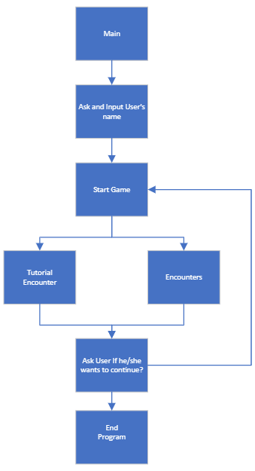

Figure 1.1 Hierarchy Chart

**C. Flowchart**

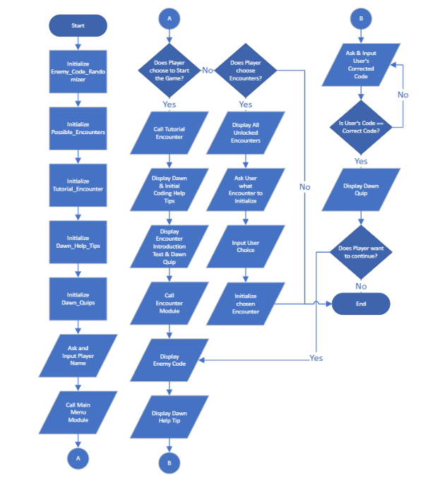

Figure 1.2 Flowchart

**D. Pseudocode**

**//** Pre-Game Initialization

1. Initialize Enemy_Code_Randomizer
2. Initialize Possible_Encounters
3. Initialize Tutorial_Encounter
4. Initialize Dawn_Help_Tips
5. Initialize Dawn_Quips
6. Ask and Input Player Name

// Main Menu

1. Call Main Menu Module
2. If Player Chooses Start Game, Proceed to Step 10, Else, Proceed to Step 9.
3. If Player Chooses Encounters, Proceed to Step 24, Else if Player chooses Exit, Stop Program
4. Display Dawn & Initial Coding Help Tips
5. Call Tutorial Encounter, Proceed to Step 16
6. Display Dawn Quips
7. Call Encounter Module, Proceed to Step 19
8. Ask if Player wants to continue with Y/N
9. Stop Program if N, Else, Proceed to Step 19

// Tutorial Encounter

1. Display Dawn & Initial Coding Help Tips
2. Display Encounter Introduction Text & Dawn Quip
3. Return to Step 12

// Encounter Module

1. Display Enemy Code
2. Display Dawn Help Tip
3. Ask & Input User's corrected code
4. If User's Code == Correct Code, Proceed to Step 23, Else Return to Step 21
5. Display Dawn Quip, Return to step 14

// Encounter Select Option

1. Display All Unlocked Encounters
2. Ask User what Encounter to initialize
3. Input User Choice
4. Initialize chosen Encounter

**IV. Results**

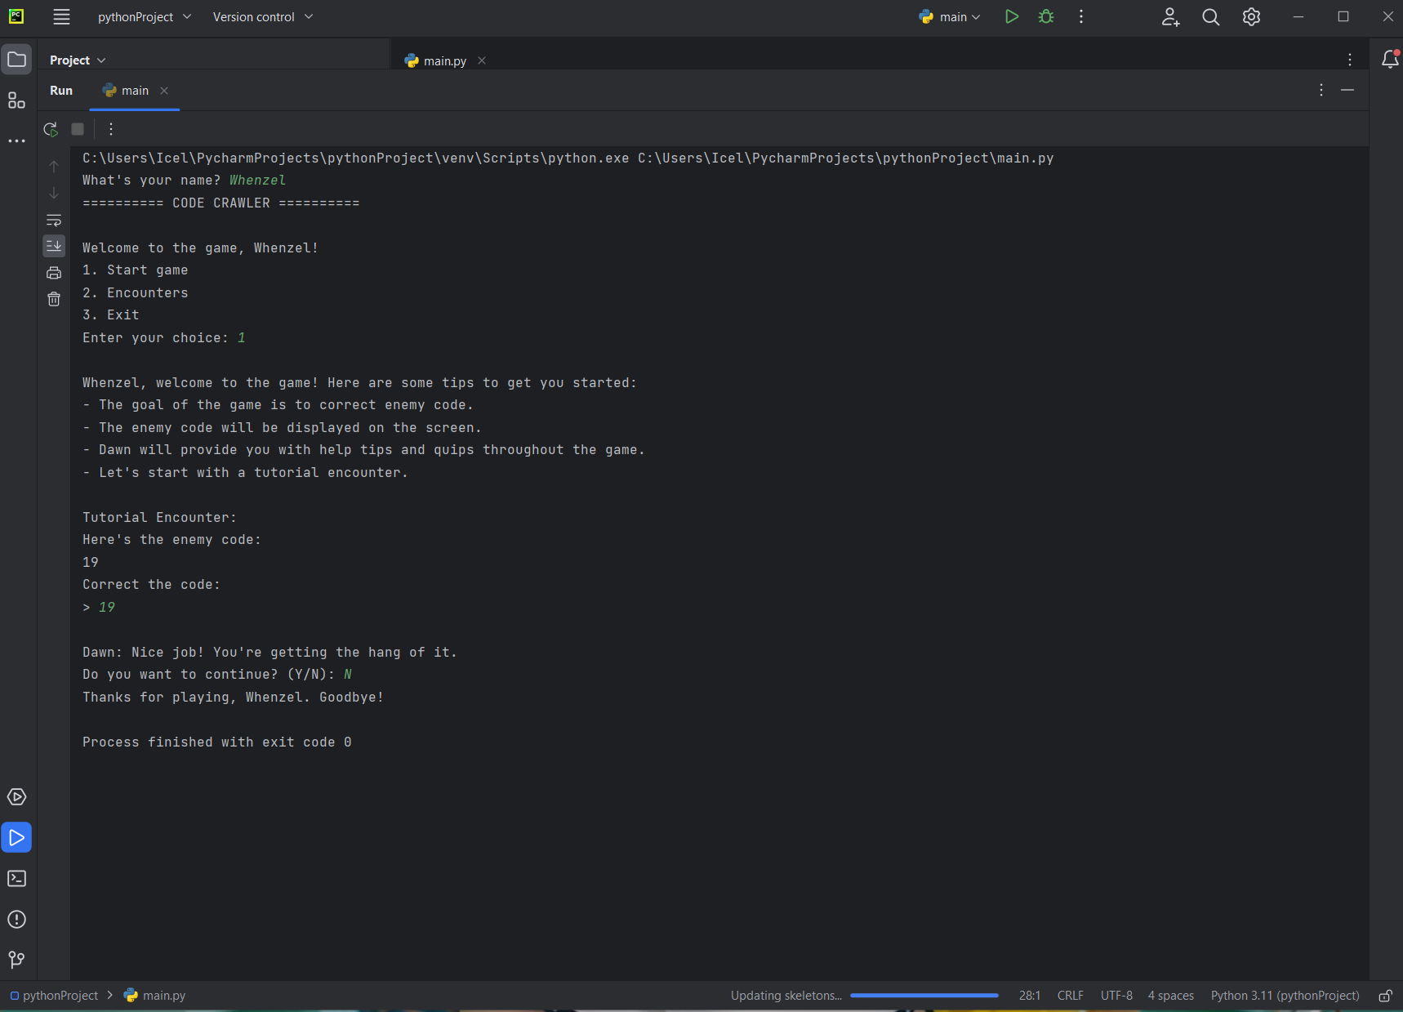

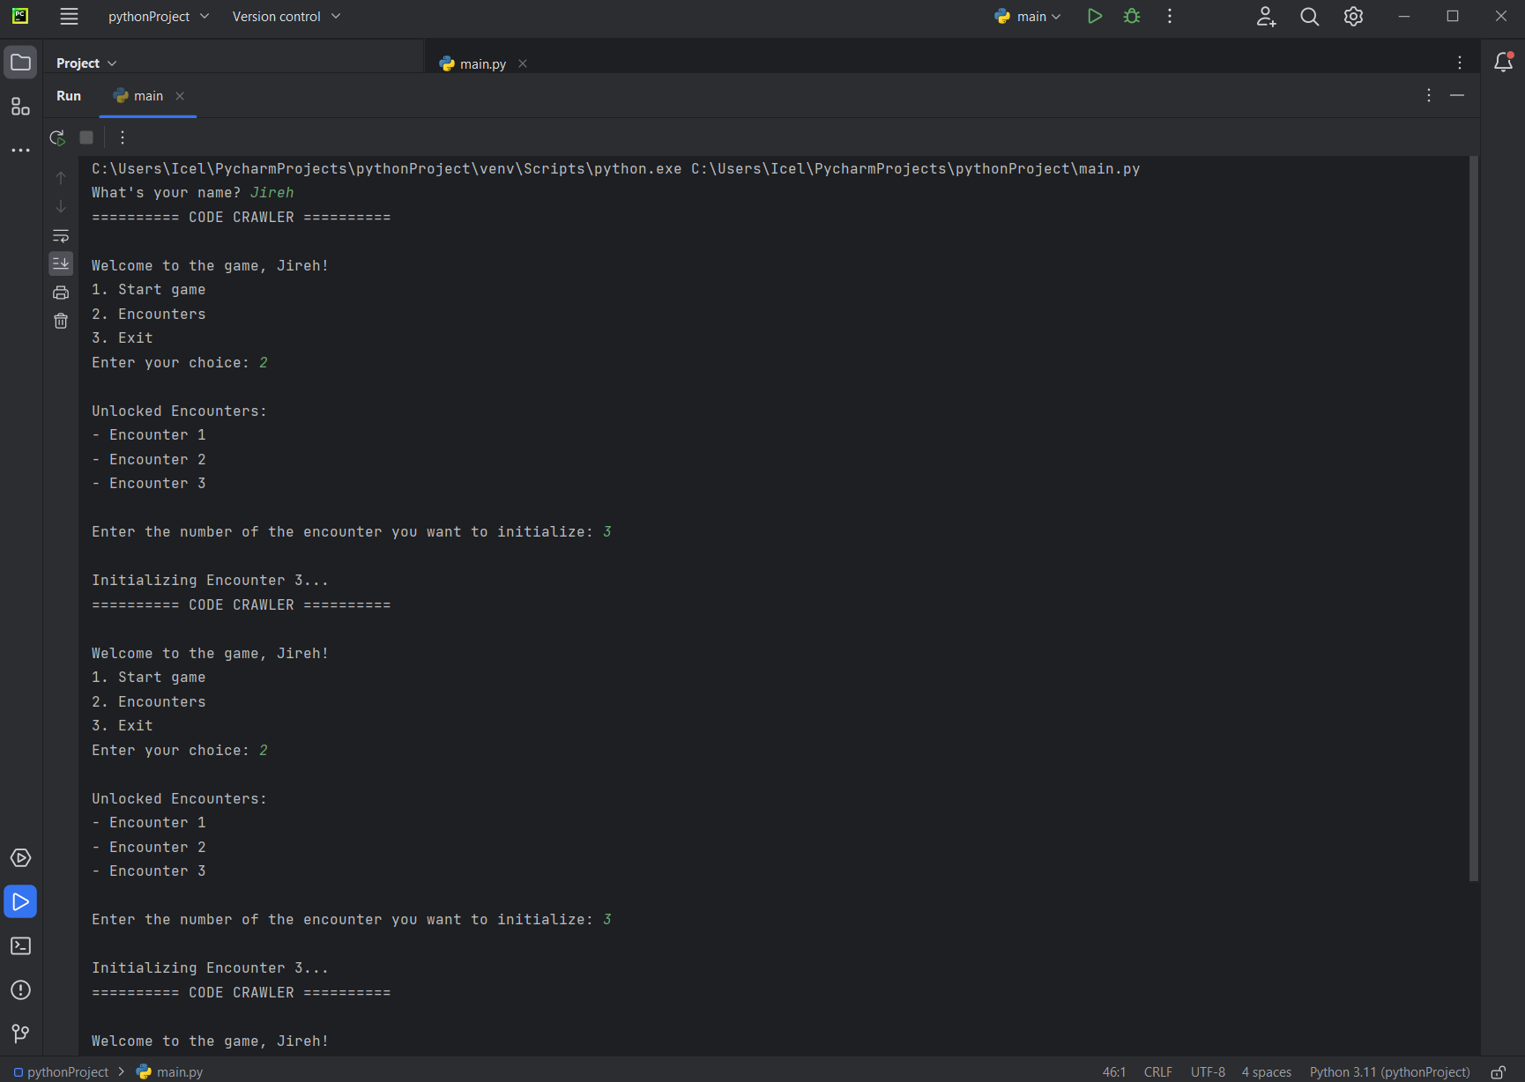

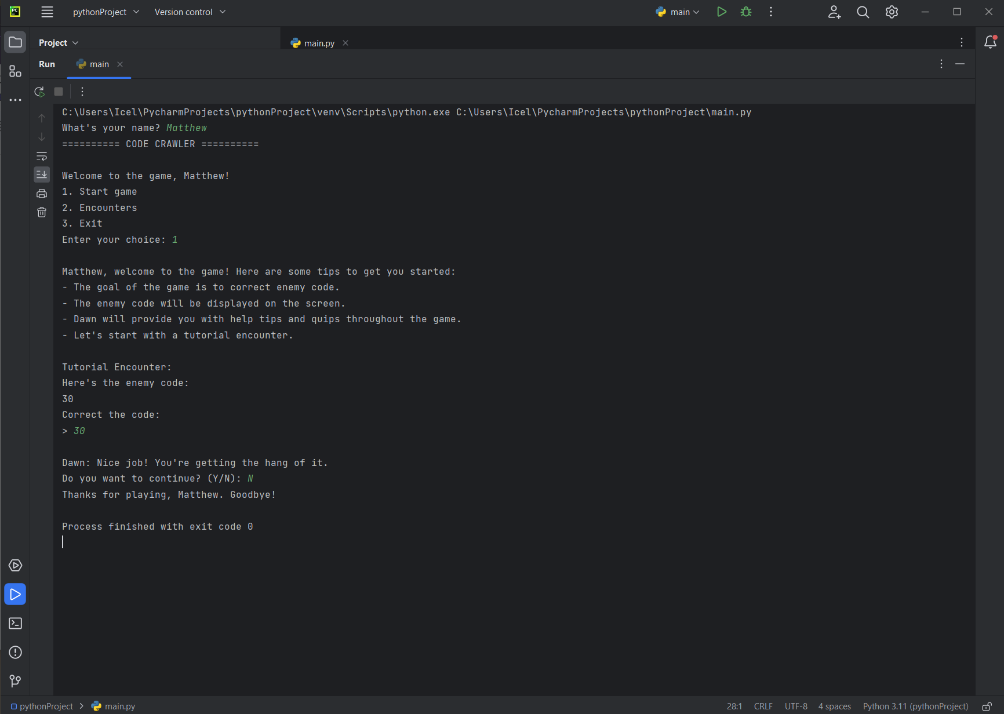

**V. Discussion of Results**

Based on the figures provided, it appears that the Code Crawlers game is running smoothly without any major issues affecting the user's experience. The game's basic functionalities, such as the ability to input the correct code, seem to be working well and allowing the user to progress through the game without any significant hiccups. Additionally, the fact that all three iterations of the game produced similar results indicates that the game is consistently performing at a high level and that any bugs or glitches that may have existed in earlier versions have been successfully addressed and resolved.

It is worth noting that despite the absence of any significant errors, there may still be some minor encounters displayed during the game. This is not necessarily a cause for concern, as even well-tested and thoroughly-debugged software can still have small issues that may not significantly impact the user's experience. Overall, the results suggest that the Code Crawlers game is in good shape and providing a solid user experience.

**VI. Analysis, Conclusion and Future Directives**

**Analysis**

The Code Crawler project is a promising attempt that aims to use a game-like interface to make Python programming approachable and entertaining for novices. A narrative plot and a companion character named Dawn provide a personalized learning environment that aids in student engagement and knowledge retention. A progress monitoring tool is also included in the game, which is crucial for determining strengths and weaknesses, improving performance over time, and assessing the learning process.

Additionally, the project's versatility and accessibility to different learning preferences and types ensure that students can understand the information and use it in real-world scenarios. The learning process is made more dynamic and engaging by adding other resources like a dictionary and forum so that students may access information and engage with one another. In general, the initiative aims to foster a love for programming by providing novice programmers with inspiration, encouragement, and a fun and engaging learning environment.

**Conclusion**

To sum up, the Code Crawler project is an encouraging effort that aims to make Python programming approachable and interesting for beginners. The project seeks to improve student engagement and information retention through the use of a game-like interface, a tailored learning environment, and progress-tracking tools. Students will learn efficiently and be able to apply their information in real-world situations because of the project's adaptability and accessibility to various learning preferences and kinds. The process of education is also made more dynamic and interesting by the addition of other resources like a dictionary and discussion board.

Overall, the Code Crawler project has the potential to significantly advance the area of computer science education by inspiring and motivating inexperienced programmers to learn more about programming and advance their abilities. People who are interested in learning programming but find it frightening or challenging may find it easier to get started thanks to the project's enjoyable and engaging learning environment. If it is a success, the Code Crawler project may have a significant influence on the future of computer science and the training of the next generation of programmers.

**Future Directives**

To further improve upon the project’s content, it is recommended to implement even more complex topics and problems from within python programming in order to further develop and foster learning from the game, following this, there could also be an implementation of a sort of “lives” system in the game, wherein the player has more incentive to win their encounters else they risk restarting the game from the beginning.

There could also be a better user interface that could be developed in python to give the player a more comfortable look at the program as they play, along with improved visuals of what Dawn or the Enemy code actually looks like when facing them in an encounter.

**References**

Cheah, C.-S. (1970, January 1). *[PDF] factors contributing to the difficulties in teaching and learning of Computer Programming: A literature review: Semantic scholar*. Contemporary Educational Technology. Retrieved April 21, 2023, from https://www.semanticscholar.org/paper/Factors-Contributing-to-the-Difficulties-in-and-of-Cheah/4b2d39de7843b96aef5cb07e7cbbb16e44f022bd

Correia, A. (2017, September 12). How to Create a Python Text-Based Game. Instructables.

<https://www.instructables.com/How-to-Create-a-Python-Text-Based-Game/>

Da Silva, J. P., Guimarães, G. V., De Góis Teixeira, L. F., & Silveira, I. F. (2020b). PYTHON DOMINATION: AN OPEN EDUCATIONAL GAME FOR LEARNING PROGRAMMING FUNDAMENTALS. *INTED2020 Proceedings*. <https://doi.org/10.21125/inted.2020.2464>

Dallas, O., & Gogoulou, A. (2022). Learning Programming Using Python: The Case of the DigiWorld Educational Game. *European Journal of Engineering and Technology Research*, 1–8. https://doi.org/10.24018/ejeng.2021.0.cie.2750

Jaiswal, D. (2021, August 13). Text-Based Adventure Game in Python. TheCoderPedia.

<https://www.thecoderpedia.com/blog/text-based-adventure-game-in-python/>

M, P., N, N. M., Dakshina, R., S, S., & R, B. S. (2020). Learning Analytics: Game-based Learning for Programming Course in Higher Education. *Procedia Computer Science*, *172*, 468–472. <https://doi.org/10.1016/j.procs.2020.05.143>

Melvin, J. (2020, May 5). 5 open source Python games to learn coding. Opensource.com.

<https://opensource.com/article/20/5/python-games>

Moser, R. (n.d.). *A fantasy adventure game as a learning environment - dl.acm.org*. Retrieved April 20, 2023, from https://dl.acm.org/doi/pdf/10.1145/268819.268853

Kroustalli, C., & Xinogalos, S. (2021). Studying the effects of teaching programming to lower secondary school students with a serious game: a case study with Python and CodeCombat. *Education and Information Technologies*, *26*(5), 6069–6095. <https://doi.org/10.1007/s10639-021-10596-y>

Raj, S. (2021, July 7). Text Based Adventure Game in Python – An Ultimate Guide for

Beginners. AskPython. <https://www.askpython.com/python/text-based-adventure-game>

Singh, A. (2021, February 22). How to Create a Text Adventure Game in Python. MakeUseOf.

<https://www.makeuseof.com/python-text-adventure-game-create/>

**Appendices**

**A. User’s Manual**

1. To begin the game, input your name.
2. You will see the main menu when the game first launches. Select whether to begin the game or to see possible encounters. The program will end if you decide to leave.
3. If you decide to begin the game, a tutorial and coding advice will be given to you. After finishing the lesson, an encounter module will be shown to you. Change the code, then carry on with the game.
4. You will get a list of unlocked encounters if you decide to view potential encounters. To begin playing and initialize, select an encounter.
5. After finishing an encounter, you will be prompted with a Y/N question. Select Y to move on to the next encounter or N to end the program.
6. The software will keep running until you decide to stop it or finish all of the encounters.

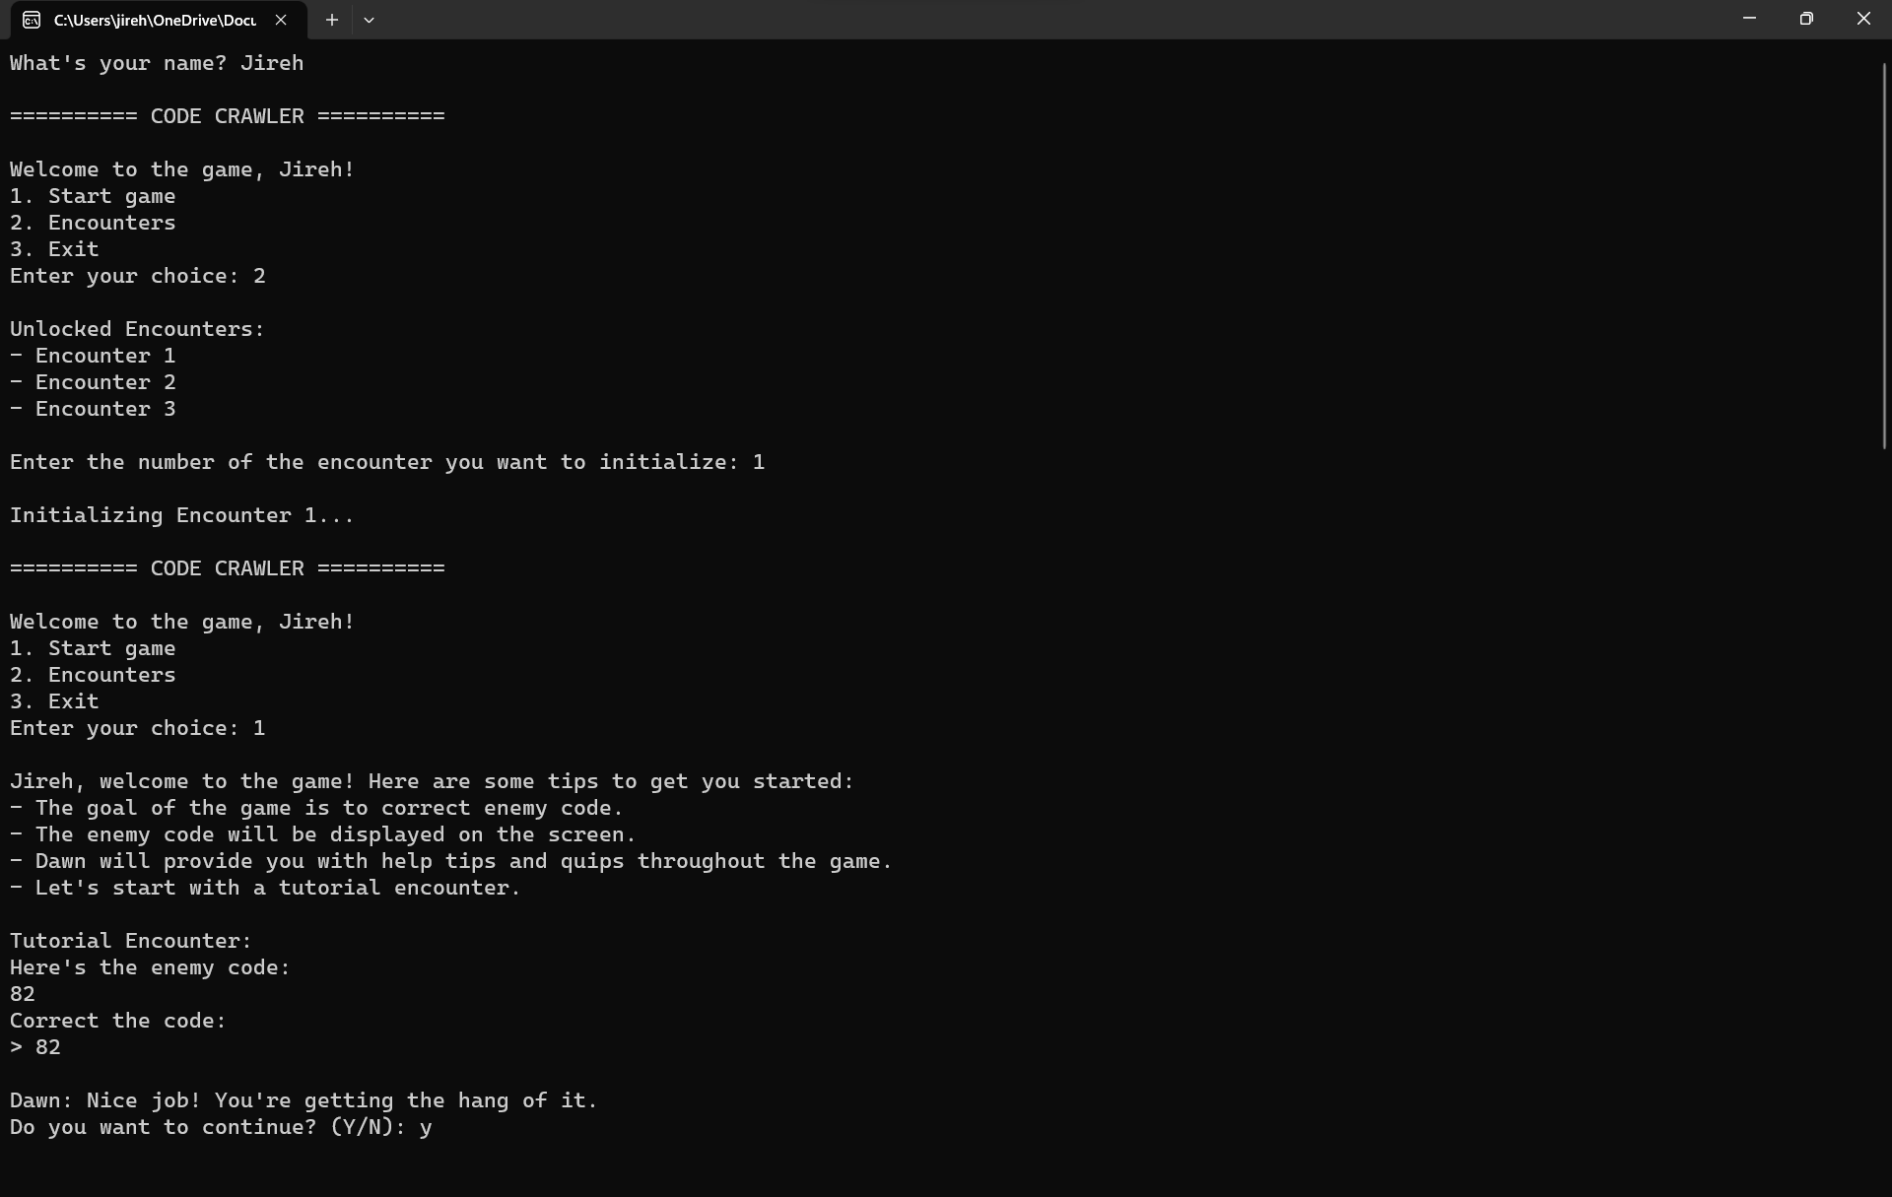

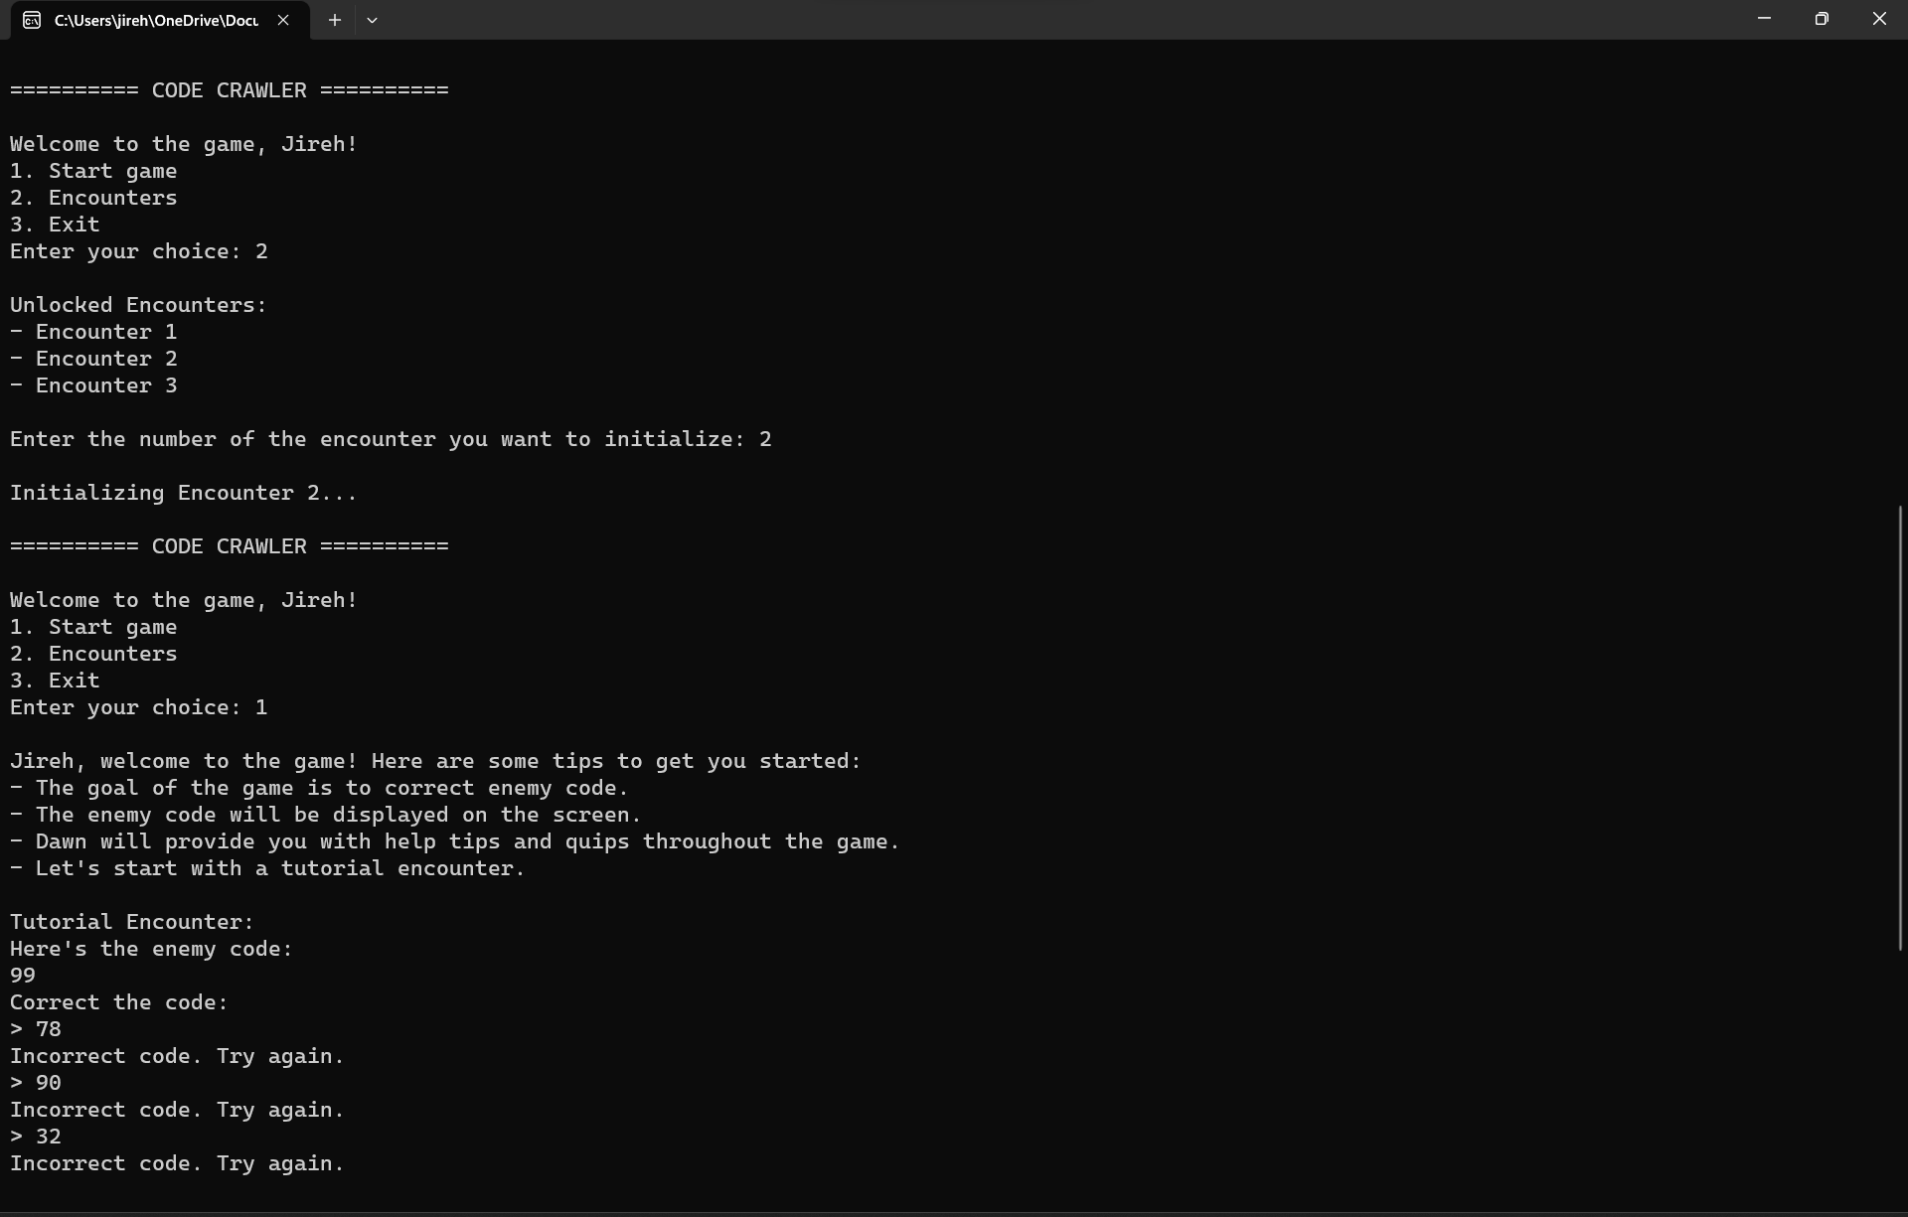

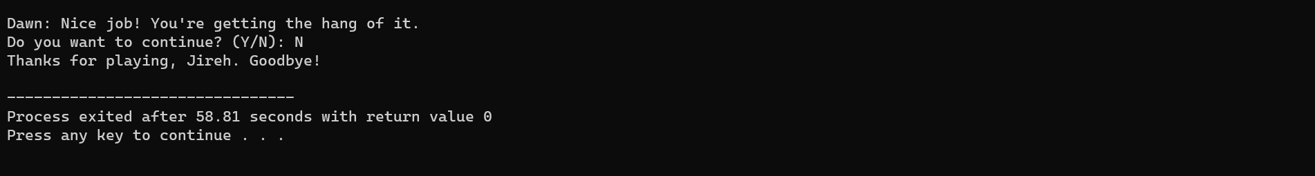

**B. Source Code**

import random

# Seed the random number generator with current time

random.seed()

# Ask and input player name

player_name = input("What's your name? ")

# Initialize variables

enemy_code_randomizer = 0

possible_encounters = 0

tutorial_encounter = 0

dawn_help_tips = 0

dawn_quips = 0

# Call main menu module

while True:

print("========== CODE CRAWLER ==========")

print(f"\nWelcome to the game, {player_name}!")

print("1. Start game")

print("2. Encounters")

print("3. Exit")

choice = int(input("Enter your choice: "))

if choice == 1:

# Display Dawn & Initial Coding Help Tips

print(f"\n{player_name}, welcome to the game! Here are some tips to get you started:")

print("- The goal of the game is to correct enemy code.")

print("- The enemy code will be displayed on the screen.")

print("- Dawn will provide you with help tips and quips throughout the game.")

print("- Let's start with a tutorial encounter.\n")

# Call Tutorial Encounter Module

print("Tutorial Encounter:")

print("Here's the enemy code:")

enemy_code_randomizer = random.randint(1, 100)

print(enemy_code_randomizer)

print("Correct the code:")

# Loop until user inputs correct code

while True:

user_code = int(input("> "))

if user_code == enemy_code_randomizer:

# Display Dawn Quip and ask if player wants to continue

print("\nDawn: Nice job! You're getting the hang of it.")

response = input("Do you want to continue? (Y/N): ")

if response.lower() == 'n':

print(f"Thanks for playing, {player_name}. Goodbye!")

exit()

break

else:

print("Incorrect code. Try again.")

elif choice == 2:

# Display all unlocked encounters

print("\nUnlocked Encounters:")

print("- Encounter 1")

print("- Encounter 2")

print("- Encounter 3")

# Ask user which encounter to initialize

encounter_choice = int(input("\nEnter the number of the encounter you want to initialize: "))

# Initialize chosen encounter

print(f"\nInitializing Encounter {encounter_choice}...")

elif choice == 3:

# Stop program

print(f"\nThanks for playing, {player_name}. Goodbye!")

exit()

else:

# Invalid choice

print("\nInvalid choice. Please enter a number between 1 and 3.")

**C. Work Breakdown**

| Student Name | Task Assigned | Percentage of the Work Contribution |
| --- | --- | --- |
| Quijano, Gill Whenzel B. | List of Figures   1. Introduction  * Background of the Study * Significance of the Project  1. Review of Related Literature 2. Methodology  * Hierarchy Chart * Results  1. Analysis, Conclusion, and Future Directives  * Conclusion  1. References 2. Appendices  * Source Code | 30% |
| Robellon, Jireh G. | Table of Contents   1. Introduction (Introductory information)  * Objectives (General Objective and Specific Objectives)  1. Review of Related Literature 2. Methodology  * A. Conceptual Framework - IPO Chart * D. Pseudocode  1. Analysis, Conclusion, and Future Directives  * Analysis  1. References 2. Appendices  * A. User’s Manual * D. Personal Data Sheet | 40% |
| Talicol, Matthew Ceazar P. | List of Tables  I. Introduction   * Problem Statement   II. Review of Related Literature  III. Methodology (Introductory information)   * C. Flowchart   V. Discussion of Results  VI. Future Directives  References  Appendices   * C. Work Breakdown * D. Personal Data Sheet | 30% |

*Table 2. Work Breakdown of Members*

**D. Personal Data Sheet** 

**Gill Whenzel B. Quijano**

ADDRESS: Block 2, Lot 25, Camella Balanga,

Central, Balanga, Bataan

EMAIL: gill_quijano@dlsu.edu.ph

CONTACT DETAILS: 09173290102

**Education**

**Highschool:**

Bataan National High School, Roman Superhighway, Bataan

**Senior High School:**

2020 – 2022

**11th – 12th Grade**

**Strand:** Science, Technology, Engineering and Mathematics (STEM).

**Junior High School:**

2016 – 2020

**7th – 10th Grade**

Special Science Class

**9th – 10th Grade**

Robotics Education

**JIREH GANANCIAL ROBELLON**

Blk 8, Lot 3, Veraville Townhomes Manuela 3A,

Pamplona Tres, Las Piňas City

jireh_robellon@dlsu.edu.ph

**PERSONAL INFORMATION**

**Gender:** Female

**Age:** 19 years old

**Birthday:** December 10, 2003

**Religion:** Roman Catholic

**Nationality:** Filipino

**Civil Status:** Single

______________________________________________________________________________

**EDUCATIONAL BACKGROUND**

**Pre-School (**2007-2009)

Jeremiah Montessori School

Phase 2, 4025 Cabuyao, Laguna

(2009-2010)

Hosanna Christian Academy

St. Joseph Village. Butong, Cabuyao, Laguna

**Elementary (**2010-2016)

Saint Therese School of Las Pinas City

27# Aurora Drive Vergonville Subdivision, Las Pinas City

**High School** (2016-2020)

Saint Therese School of Las Pinas City 27# Aurora Drive Vergonville Subdivision, Las Pinas City

**Senior High** (2020-2022)

**School** Divine Light Academy - Las Pinas Branch

7 Rosal Street Doña Manuela Subdivision Las Piñas City 1740

Philippines

**SKILLS**

* Can speak and understand English and Filipino language. And knows a little bit of Korean
* Can dance and sing
* Can play instruments such as Guitar, Piano, Drums, and Ukulele
* Can play Volleyball and other sports
* Can write poems, essays, and stories
* Experienced in Multimedia Arts
* Leadership skills
* Fully comprehensive in any kind of information
* Skilled in computer literacy
* Has wide vocabulary and good memory

**MATTHEW CEAZAR P. TALICOL**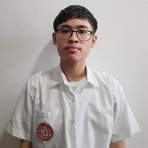

Address: Nia Road, Labac, Naic, Cavite

Email: matthew_talicol@dlsu.edu.ph

______________________________________________________________________________

**PERSONAL INFORMATION**

**Gender:** Male

**Age:** 19 years old

**Birthday:** January 19, 2004

**Religion:** Roman Catholic

**Nationality:** Filipino

**Civil Status:** Single

______________________________________________________________________________

**EDUCATION**

Pre-school

Kindergarten Abeniano Delos Santos Academy Inc.

Preparatory Abeniano Delos Santos Academy Inc.

Elementary

Grade 1 Abeniano Delos Santos Academy Inc.

Grade 2 Abeniano Delos Santos Academy Inc.

Grade 3 Abeniano Delos Santos Academy Inc.

Grade 4 Abeniano Delos Santos Academy Inc.

Grade 5 Abeniano Delos Santos Academy Inc.

Grade 6 Abeniano Delos Santos Academy Inc.

Highschool

Grade 7 Cavite Science Integrated School

Grade 8 Cavite Science Integrated School

Grade 9 Cavite Science Integrated School

Grade 10 Cavite Science Integrated School

Senior Highschool

Grade 11 Cavite Science Integrated School

Grade 12 Cavite Science Integrated School

College (1st Year)

1st Term De La Salle University Manila

2nd Term De La Salle University Manila